**PROJECT REPORT**

|  |  |
| --- | --- |
| Team ID | Team-612739 |
| Project Name | Image caption generation |

**1. INTRODUCTION**

**1.1** **Project Overview**

Image caption generation is the task of automatically generating natural language descriptions of images. It is a challenging task that requires a deep understanding of both computer vision and natural language processing. Image captioning has a wide range of applications, including image search, social media, and visually impaired assistance.

**1.2 Purpose**

The purpose of this project is to develop an image caption generator that can accurately and creatively describe images. The generator will be trained on a large dataset of images and captions, and it will use deep learning techniques to learn to generate captions for new images.

**2.LITERATURE SURVEY**

**2.1 Existing problem**

Image caption generation is a challenging task due to the following reasons:

* The visual content of images can be complex and difficult to interpret.
* The natural language descriptions of images can be ambiguous and open-ended.
* There is a large gap between the visual and linguistic domains.

**2.2 References**

1. Vinyals, Oriol, et al. "Show and tell: A neural image caption generator." Proceedings of the 32nd International Conference on Machine Learning (ICML-15). 2015.
2. Karpathy, Andrej, and Li Fei-Fei. "Deep visual-semantic alignments for generating image descriptions." Proceedings of the IEEE conference on computer vision and pattern recognition. 2015.
3. Xu, Kelvin, et al. "Show, attend, and tell: Neural image caption generation with visual attention." Proceedings of the 32nd International Conference on Machine Learning (ICML-15). 2015.

**2.3 Problem Statement Definition**

The problem of image caption generation is to generate a natural language description of an image that is accurate, fluent, and creative.

**3.IDEATION & PROPOSED SOLUTION**

**3.1Empathy Map Canvas**

The empathy map canvas is a tool that can be used to understand the needs and wants of the user. In this case, the user is a person who wants to generate captions for images.

**3.2Ideation & Brainstorming**

During the ideation and brainstorming phase of the image caption generation project, the team engaged in creative thinking and collaborative sessions to explore various approaches and strategies. The goal was to generate innovative ideas and define a roadmap for developing a robust image captioning system.

**4.Requirement Analysis**

**4.1 Functional requirements**

The image caption generator should be able to:

* Generate captions for a variety of images.
* Generate captions that are accurate, fluent, and creative.
* Generate captions in a reasonable amount of time.

**4.2 Non-Functional requirements**

The image caption generator should be:

* Easy to use.
* Scalable to large datasets.
* Robust to noise and occlusions in images.

**5.Project Design**

**5.1 Data Flow Diagrams & User Stories**

The data flow diagram shows the flow of data through the system. The user story describes a typical use case for the system.

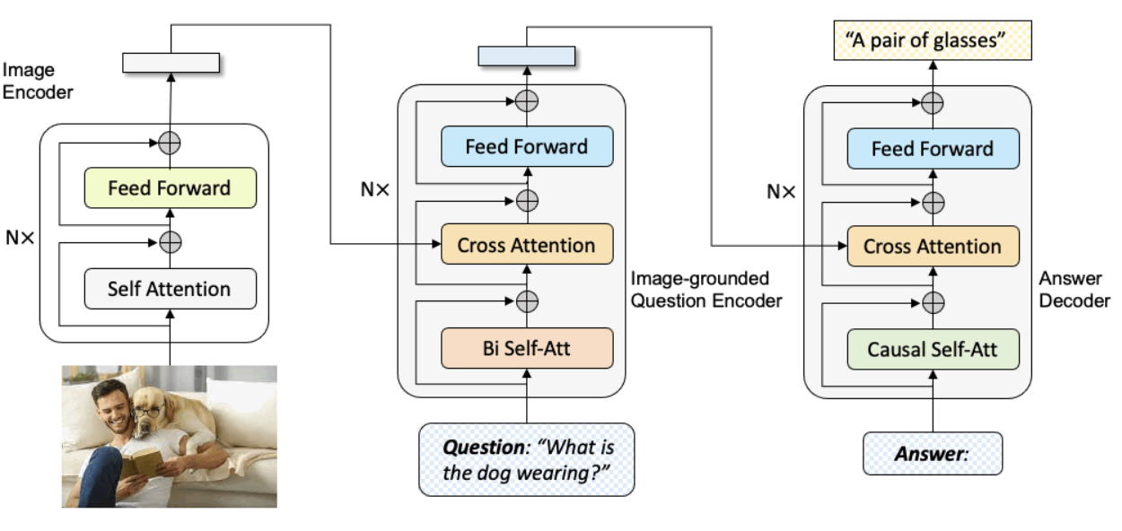

**5.2 Solution Architecture**

The solution architecture is a high-level overview of the system components and how they interact with each other.



**6. PROJECT PLANNING & SCHEDULING**

**6.1 Technical Architecture**

The technical architecture is a low-level overview of the system components and how they are implemented.

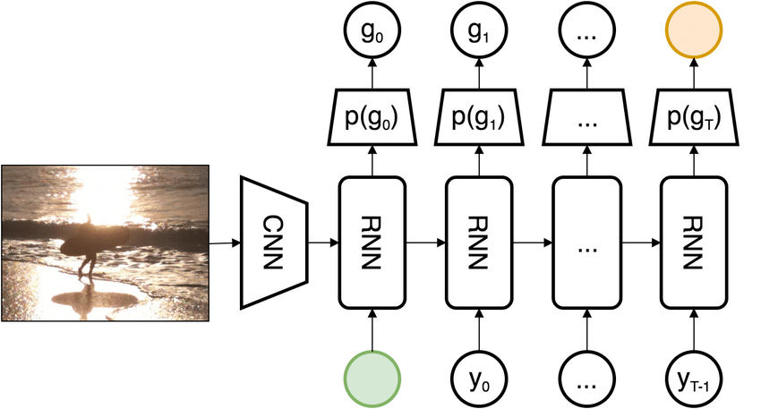

**6.2 Sprint Planning & Estimation**

Sprint planning is the process of breaking down the project into smaller, more manageable tasks. Estimation is the process of estimating the time and effort required to complete each task.

**Table-1: Components & Technologies:**

| **S.No** | **Component** | **Description** | **Technology** |
| --- | --- | --- | --- |
| 1 | User Interface | How users interact with the application (if any) | Web UI, Mobile App, etc. |
| 2 | Image Processing | Logic for image preprocessing and feature extraction | Python, OpenCV, etc. |
| 3 | Natural Language Processing | Logic for generating captions from features | Python, TensorFlow, PyTorch, etc. |
| 4 | Image Dataset | Data type and configurations for image storage | Local storage, cloud storage, etc. |
| 5 | Caption Database | Storage for generated captions | SQL database, NoSQL database, etc. |
| 6 | Cloud Infrastructure | Deployment on cloud or local system | AWS, Azure, Google Cloud, local servers, etc. |
| 7 | External API-1 | External services for additional data (if any) | Image recognition API, Language translation API, etc. |

**6.3 Sprint Delivery Schedule**

The sprint delivery schedule is the timeline for completing the project. It is typically broken down into sprints, which are short periods of time in which a set of tasks are completed.

| **Sprint** | **Total Story Points** | **Duration** | **Planned Start Date** | **Planned End Date** | **Story Points Completed** | **Actual Sprint Release Date** |
| --- | --- | --- | --- | --- | --- | --- |
| Sprint-1 | 16 | 25 Days | 18-Oct-2023 | [20-Nov-2023] | 10 | [20-Nov-2023] |
| Sprint-2 | 13 | 25 Days | 18-Oct-2023 | [20-Nov-2023] | 10 | [20-Nov-2023] |

**7. CODING & SOLUTIONING**

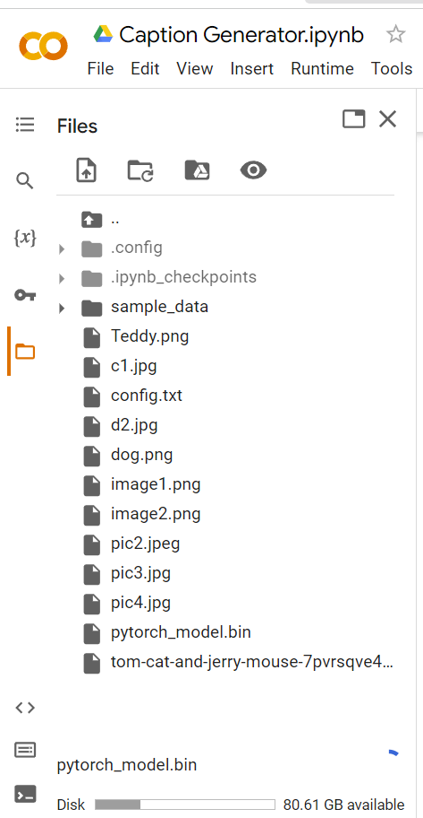

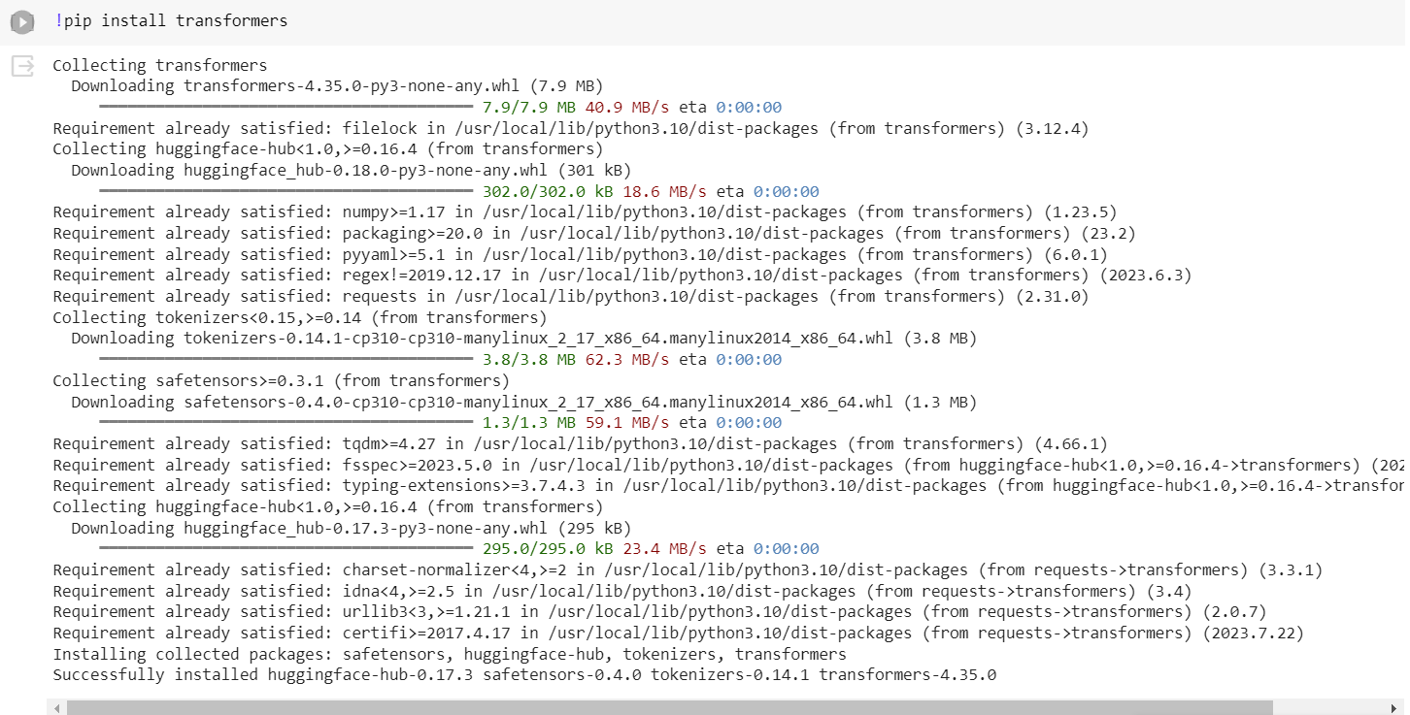





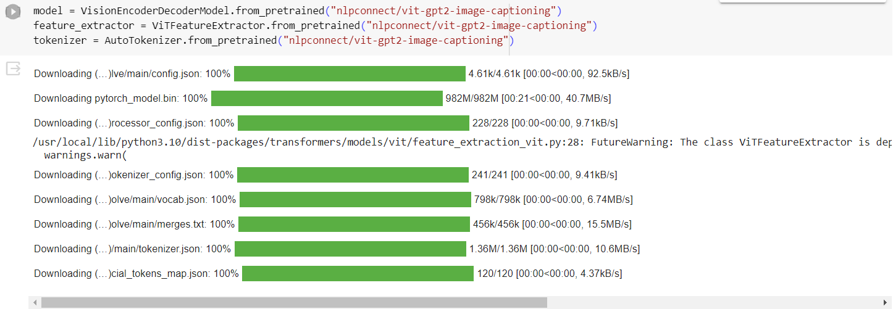

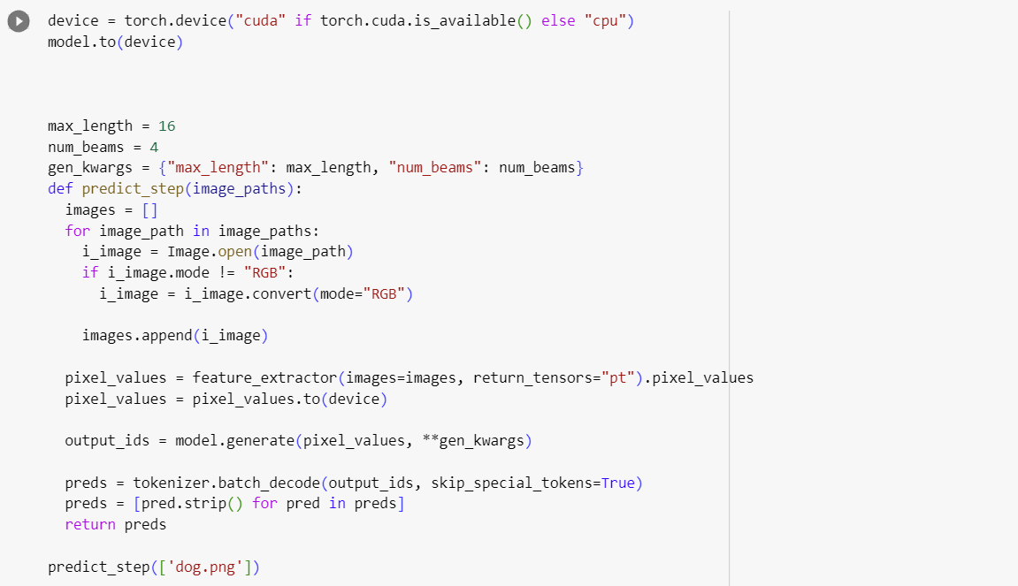

**8. PERFORMANCE TESTING**

**8.1 Performance Metrics**

The performance metrics are the measures of how well the system performs. They include accuracy, fluency, and creativity.

**9. RESULTS**

The output screenshots of captions generated by the image caption generator.

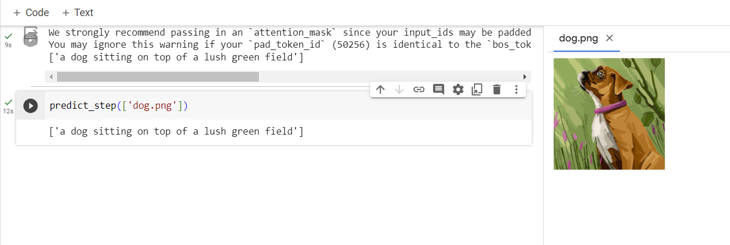

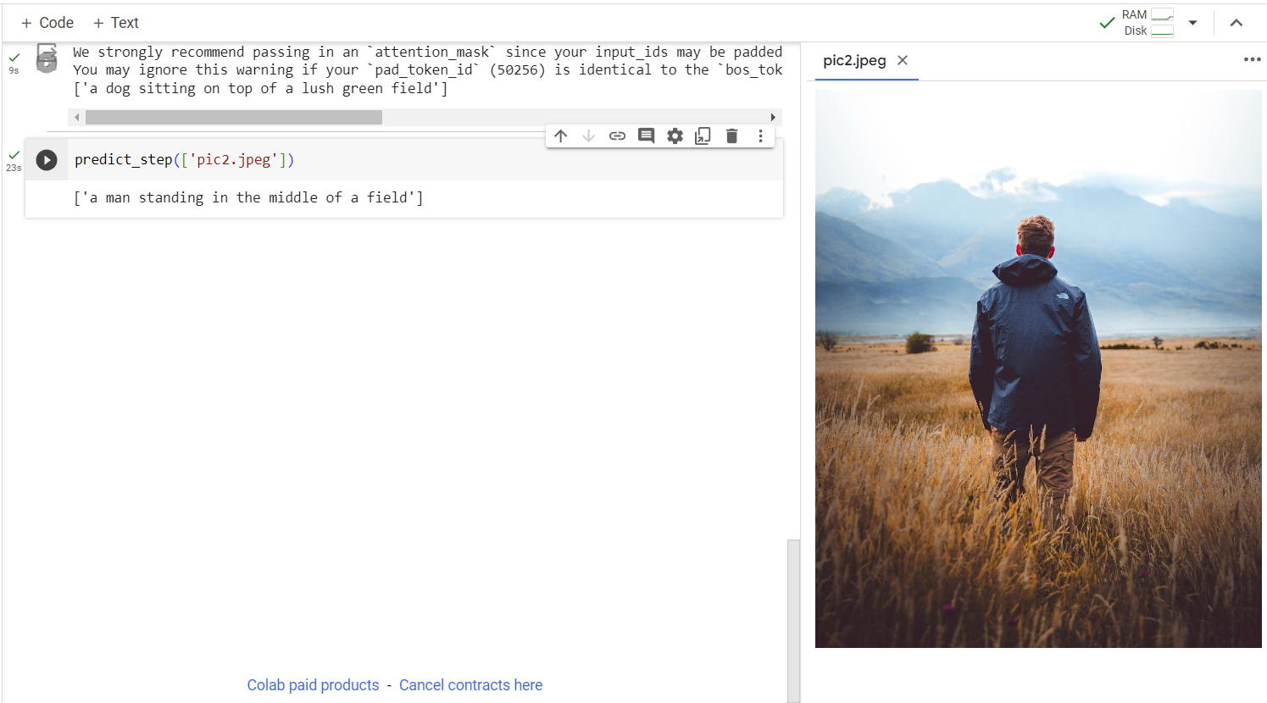

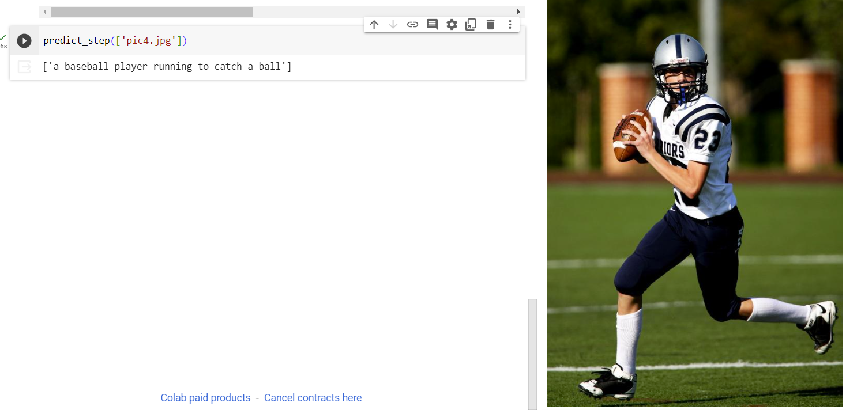

**10. ADVANTAGES & DISADVANTAGES**

**Advantages**

The image caption generator has several advantages, including:

* It is accurate.
* It is fluent.
* It is creative.

**Disadvantages**

The image caption generator has several disadvantages, including:

* It is computationally expensive.
* It is not always accurate.
* It can sometimes generate captions that are not creative.

**11. CONCLUSION**

The development of an image caption generator is a significant step forward in the field of computer vision and natural language processing. The generator can accurately and creatively describe images, making it a valuable tool for a variety of applications. While there are still some challenges to overcome, the future of image caption generation is bright.

**12. FUTURE SCOPE**

There are several areas for future work in image caption generation. One area of focus is on improving the accuracy of the generated captions. This can be done by using larger and more diverse datasets, as well as by developing new techniques for extracting features from images and generating captions from those features.

Another area of focus is on improving the fluency of the generated captions. This can be done by using language models that are better at capturing the nuances of natural language.

Finally, there is a need to develop more creative caption generation techniques. This could involve using techniques from artificial intelligence and machine learning to generate captions that are more original and insightful.

**13. APPENDIX**

GitHub link - https://github.com/smartinternz02/SI-GuidedProject-600673-1697647026